Christopher ROBERTS
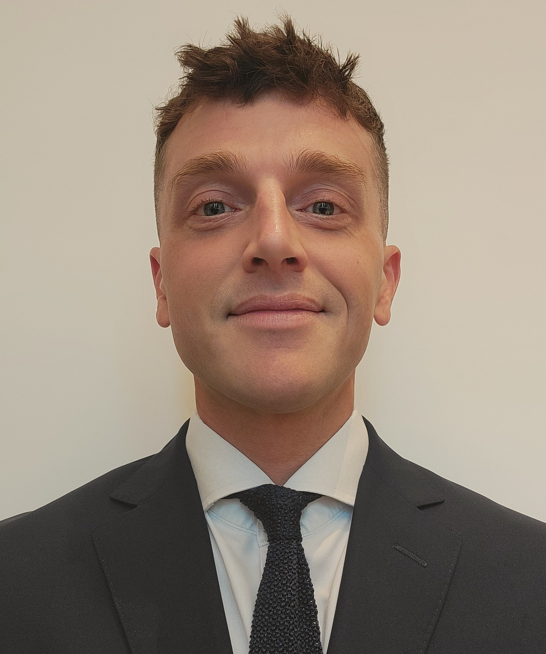

Nationality: British
IT Skills: Microsoft Office
Language Skills: English (Native)

PROFESSIONAL EXPERIENCE
Nov 2022 – Nov 2025 UBS, Hong Kong
Investment Bank, Global Markets
Head of AsiaEx Japan Cash Equity Risk Trading
- Managed a team of four traders (Hong Kong and Singapore), deploying UBS balance sheet to provide both proactive and reactive liquidity to clients.
- Designed and implemented client focused liquidity initiatives, contributing to UBS Cash Equity market share improvement to #3 (Q225) from #6 (Q323).

Oct 2018 – Nov 2022 UBS, London, UK
Investment Bank, Global Markets
Head of EMEA Small & Midcap Cash Equity Risk Trading
- Managed a team of three traders (UK and Frankfurt), directing UBS balance sheet capital commitment and agency order flow.
- Responsible for coordinating and driving client engagement, content and franchise growth initiative. Grew net commission revenues by 10% p.a. through market share and profitability improvements.

Jul 2009 – Sep 2018 Credit Suisse, London, UK
Investment Bank, Global Markets
Cash Equity Trader
- Joined as a graduate. Responsible for sector capital commitment, client focused growth initiatives and market content.

EDUCATION
Sep 2025 – Present Les Roches Global Hospitality Education, Marbella, Spain
Diploma in Advanced Studies in International Hospitality Management

Sep 2006 – July 2009 University of Manchester, Manchester, UK
BA(Econ) Economics and Finance, First Class

EXTRA-CURRICULAR EXPERIENCE

Jan 2006 – Mar 2006 Martyr’s Memorial School, Popendetta, Papua New Guinea
Teacher

SKILLS
- Client Engagement | Developed from being primary contact across two regions at UBS regarding client requests and negotiations.
- Strategic Thinking | Experience analysing market and competitive landscape and designing initiative to growth profitable market share.
- Crisis Management | Primary contact for UBS APAC trading error management. Coordinated financial, operational and regulatory risk and resolutions.
- Team Leadership | Managed remote and in-person multicultural teams across two continents
- Problem-Solving | Designed custom client liquidity solutions. Led front-to-back design, testing and implementation of new operational system at UBS.

